*TBC Log* User Manual

The TBCLog application displays the history of actions recorded by the *Talkbox Configuator*. All such events (like button presses and configuration loads) are timestamped and class-named.

The dropdown down menu will display three buttons: *Open Log Folder*, *Reset Log*, and *Export Log*. The log folder is simply the contained in the *TalkboxData* directory. In this case, only configuration logs are loaded. The reason we cannot use a notepad for these operations is because there are multiple log files, recorded over many uses. Thus, resetting these logs and exporting them into one file are automated with this application.

*The initial application state*

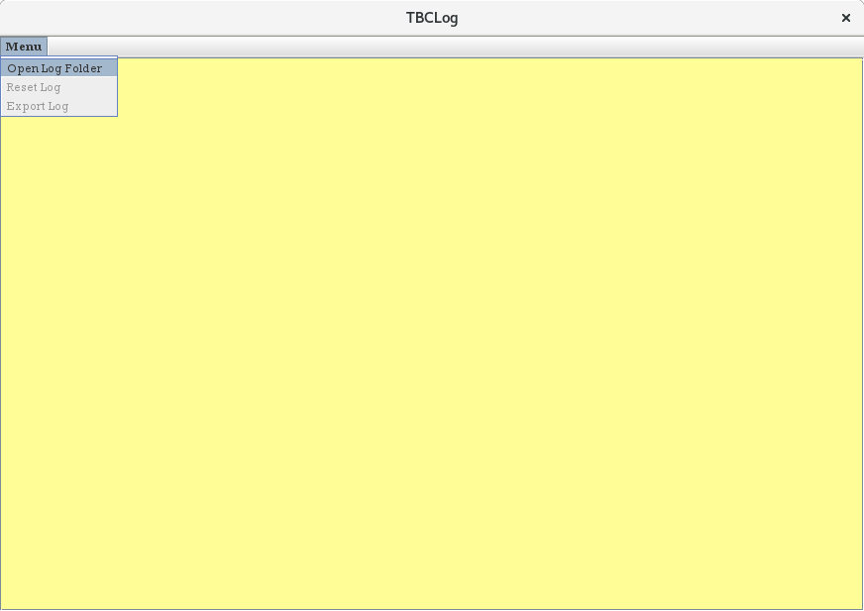

To open the configuration logs, please press Open Log Folder. Locate to the TalkboxData directory and hit logs.

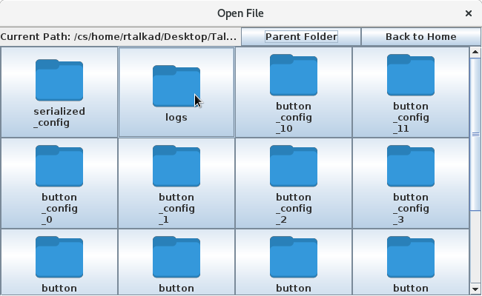

Now all the configuration logs will be loaded. If the logs are too long and one wishes to reset everything, press Reset Logs. On the other hand, if one wants to export these logs, press Export Logs and select which directory you would like to them to place them in. The file will be called EXPORTED_LOGS.

